BANK LOAN REPORT QUERY DOCUMENT

1. BANK LOAN REPORT | SUMMARY

**KPI’S:**

Total Loan Applications

SELECT COUNT (id) AS total_loan_application

FROM financial_loan

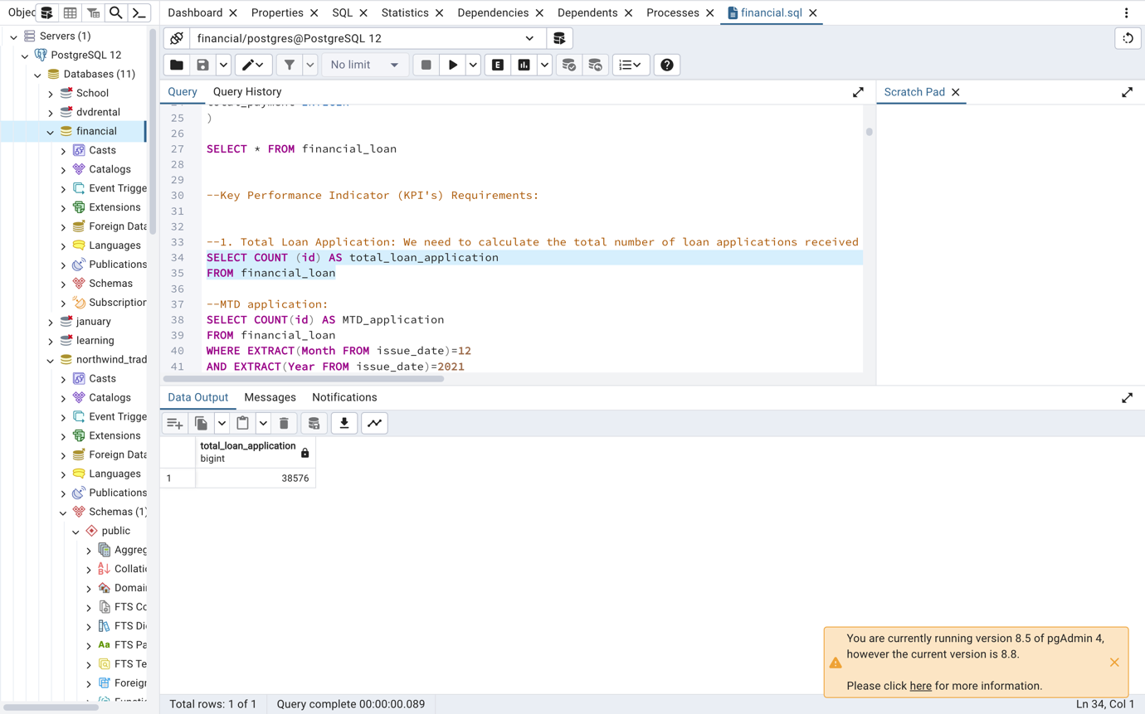

MTD Loan Applications

SELECT COUNT(id) AS MTD_application

FROM financial_loan

WHERE EXTRACT(Month FROM issue_date)=12

AND EXTRACT(Year FROM issue_date)=2021

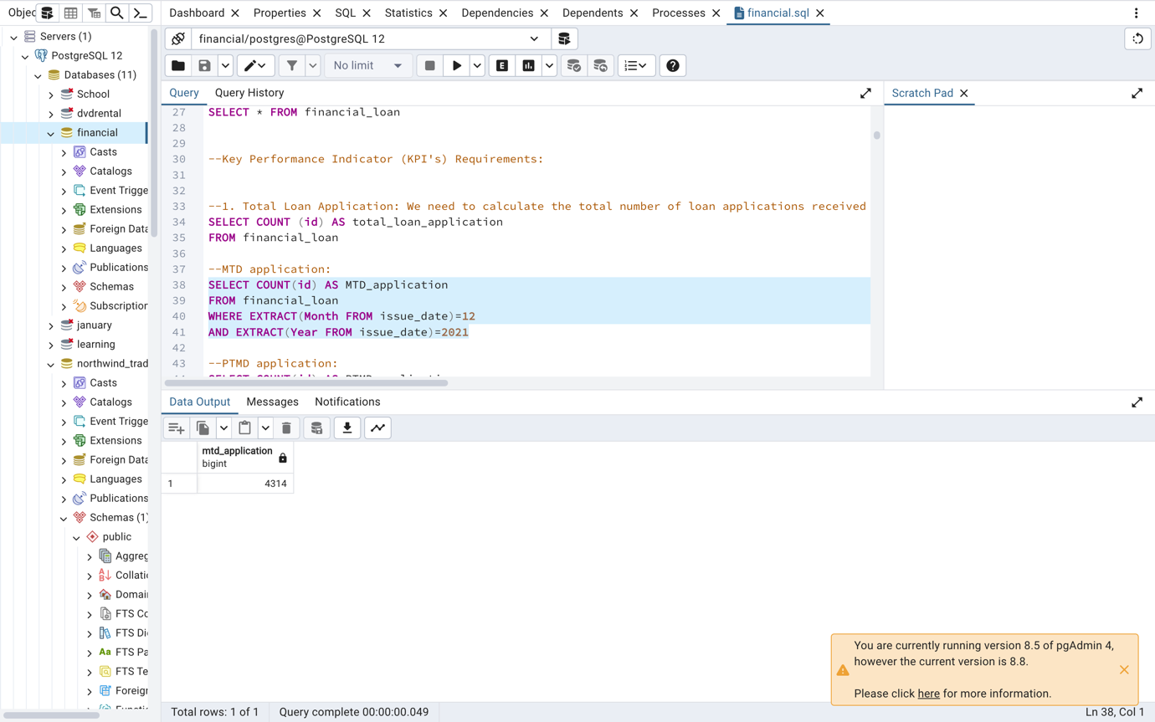

PMTD Loan Applications

SELECT COUNT(id) AS PTMD_application

FROM financial_loan

WHERE EXTRACT(Month FROM issue_date)=11

AND EXTRACT (Year FROM issue_date)=2021

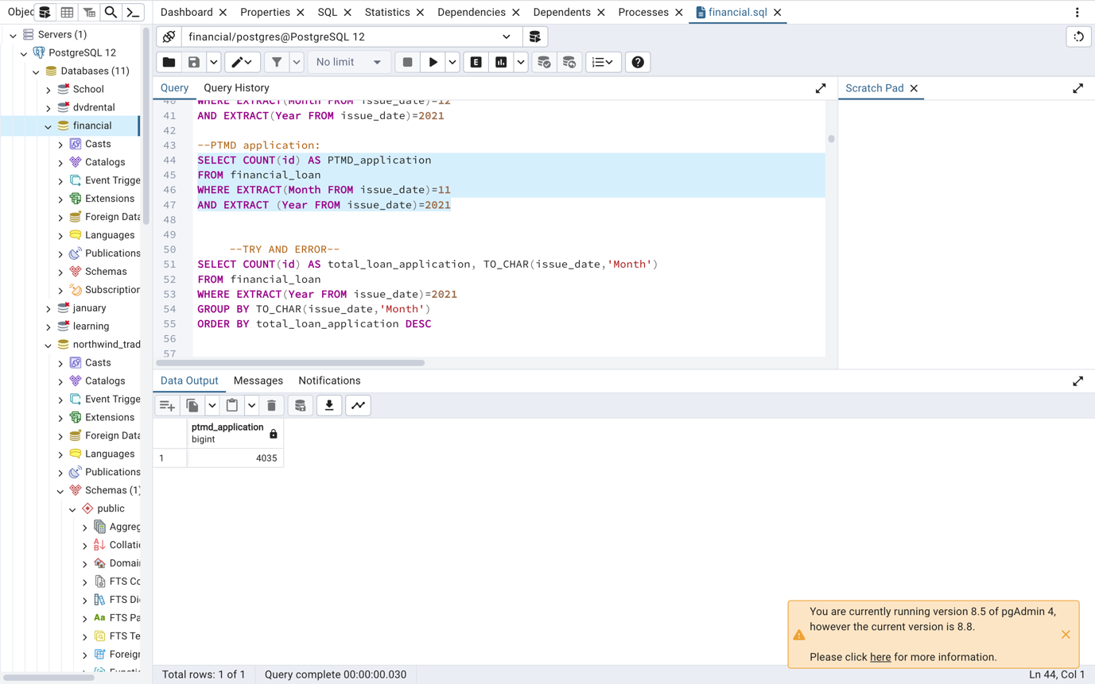

Total Funded Amount

SELECT SUM(loan_amount) AS total_funded_amount

FROM financial_loan

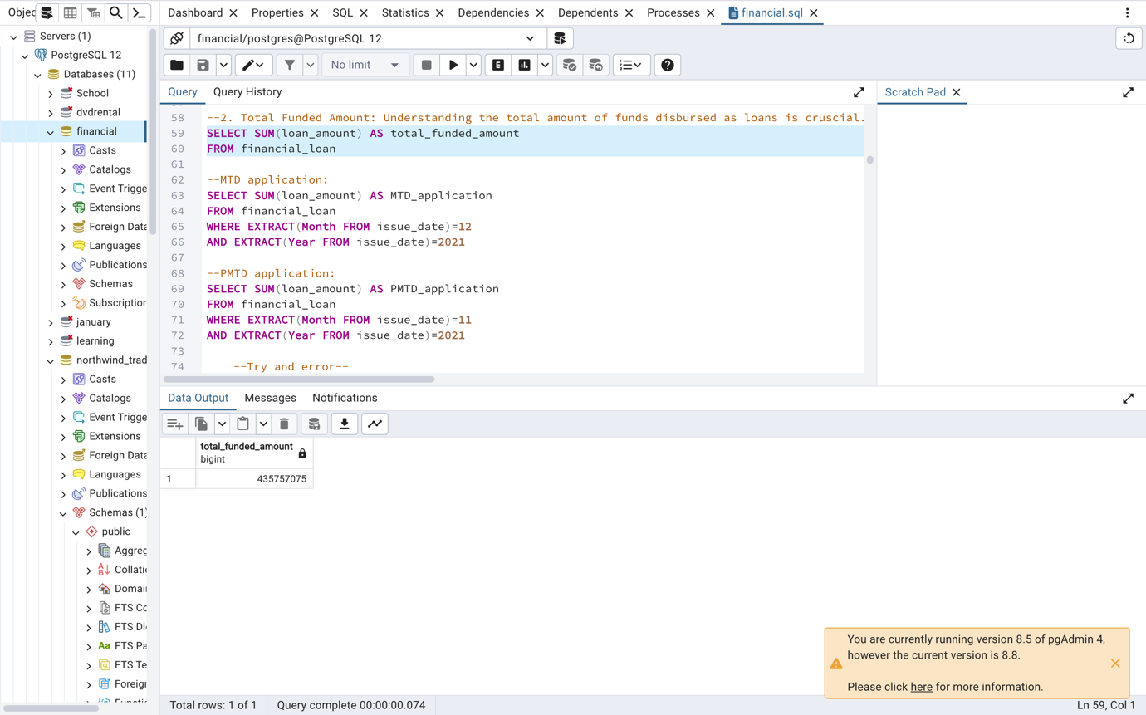

MTD Total Funded Amount

SELECT SUM(loan_amount) AS MTD_application

FROM financial_loan

WHERE EXTRACT(Month FROM issue_date)=12

AND EXTRACT(Year FROM issue_date)=2021

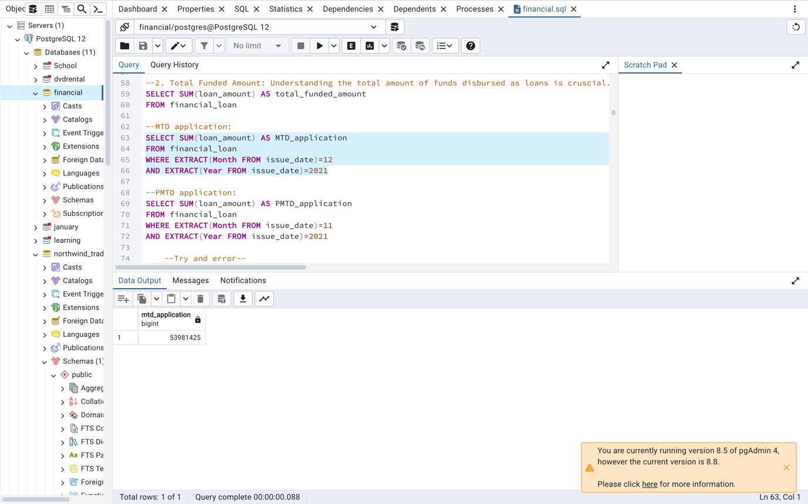

PMTD Total Funded Amount

SELECT SUM(loan_amount) AS PMTD_application

FROM financial_loan

WHERE EXTRACT(Month FROM issue_date)=11

AND EXTRACT(Year FROM issue_date)=2021

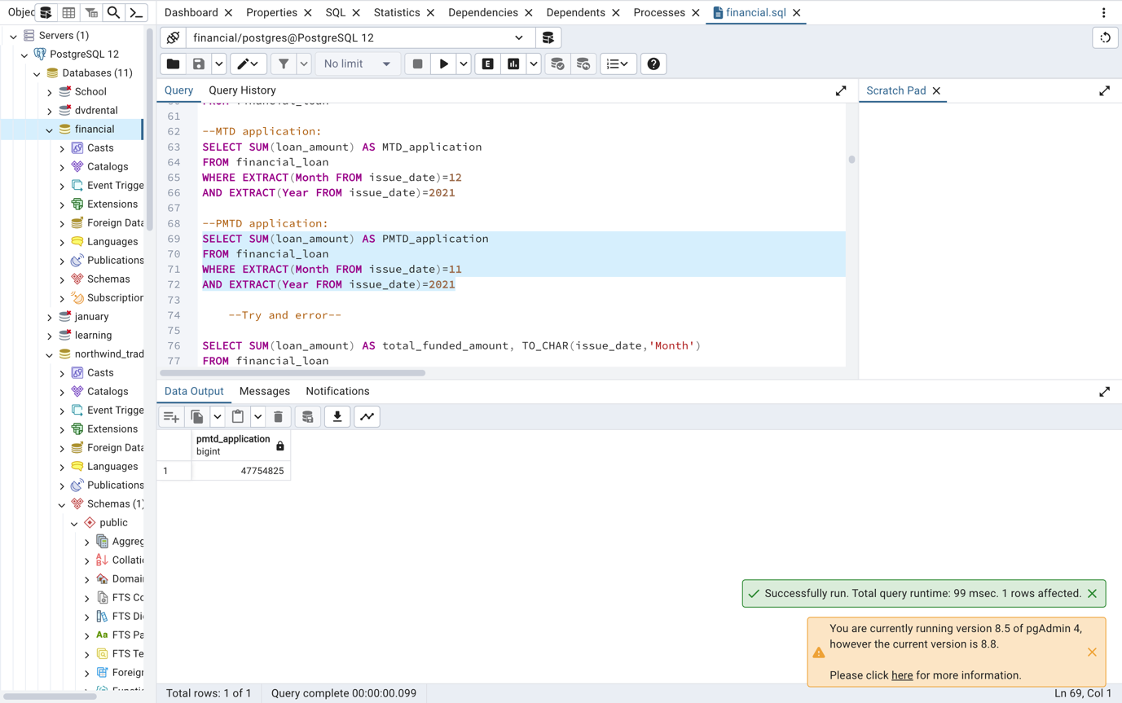

Total Amount Received

SELECT SUM(total_payment) AS total_amount_received

FROM financial_loan

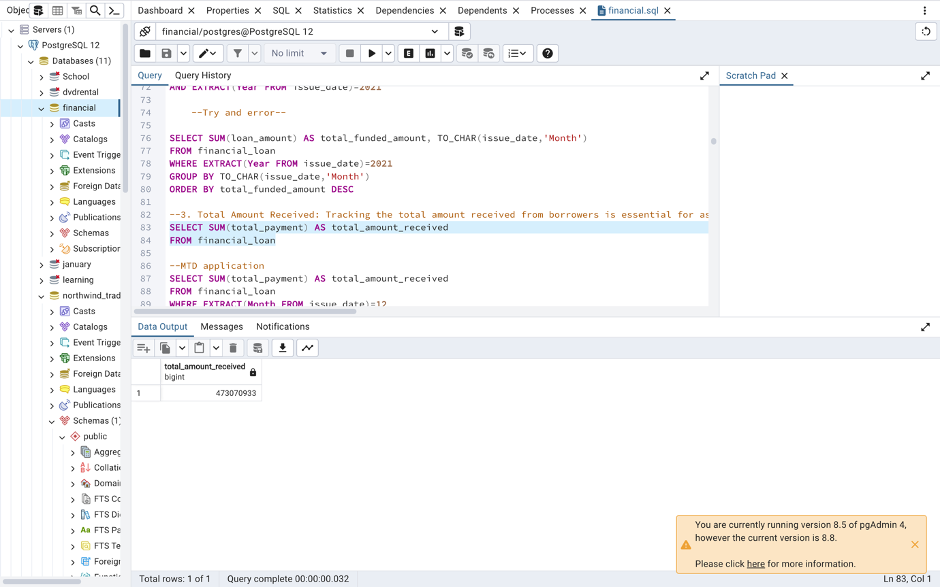

MTD Total Amount Received

SELECT SUM(total_payment) AS total_amount_received

FROM financial_loan

WHERE EXTRACT(Month FROM issue_date)=12

AND EXTRACT(Year FROM issue_date)=2021

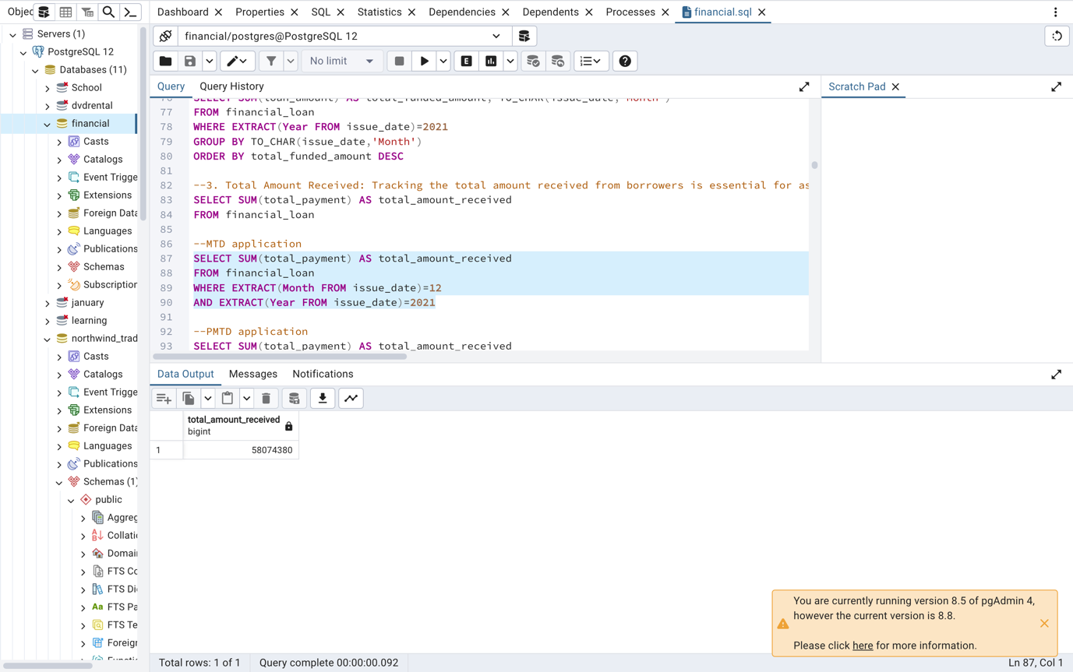

PMTD Total Amount Received

SELECT SUM(total_payment) AS total_amount_received

FROM financial_loan

WHERE EXTRACT(Month FROM issue_date)=11

AND EXTRACT(Year FROM issue_date)=2021

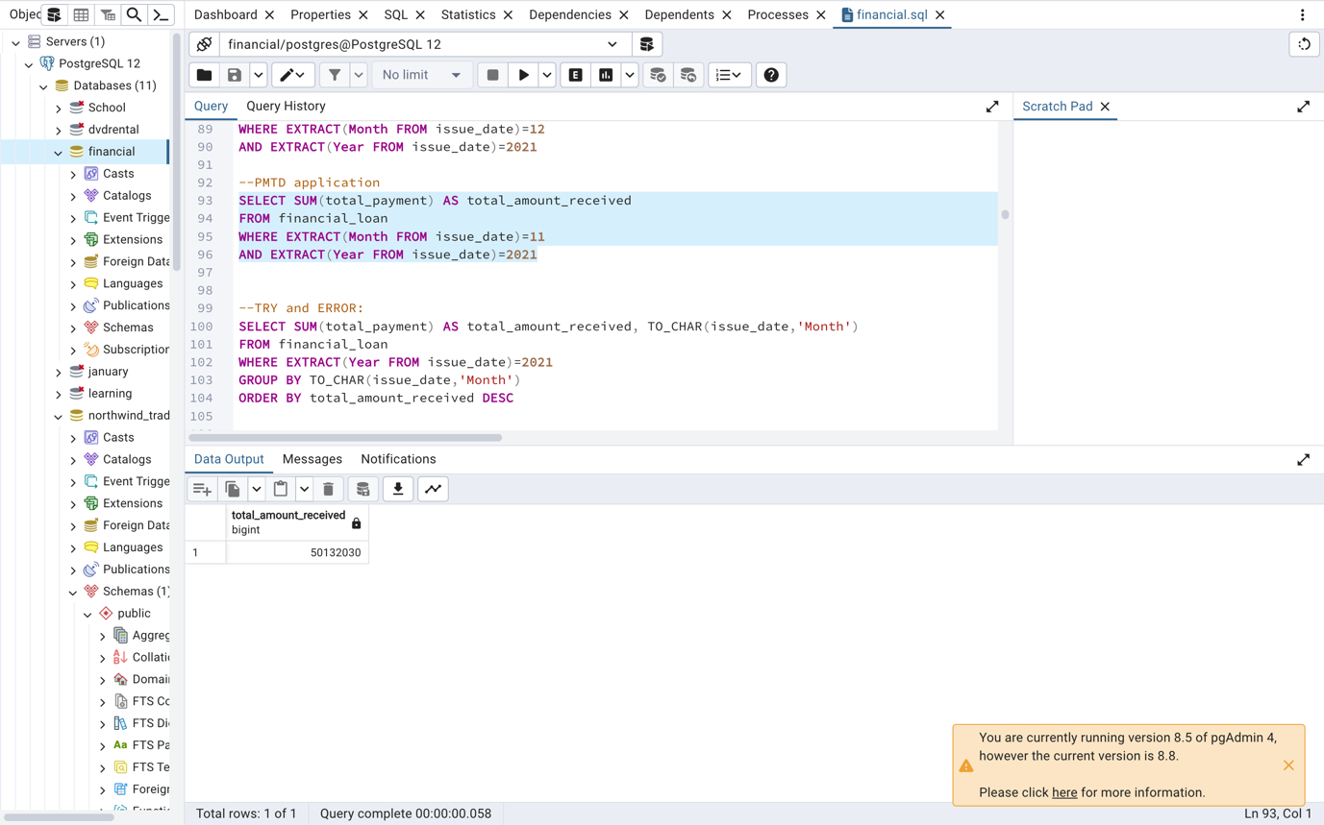

Average Interest Rate

SELECT AVG(int_rate) *100 AS AVG_DTI

FROM financial_loan

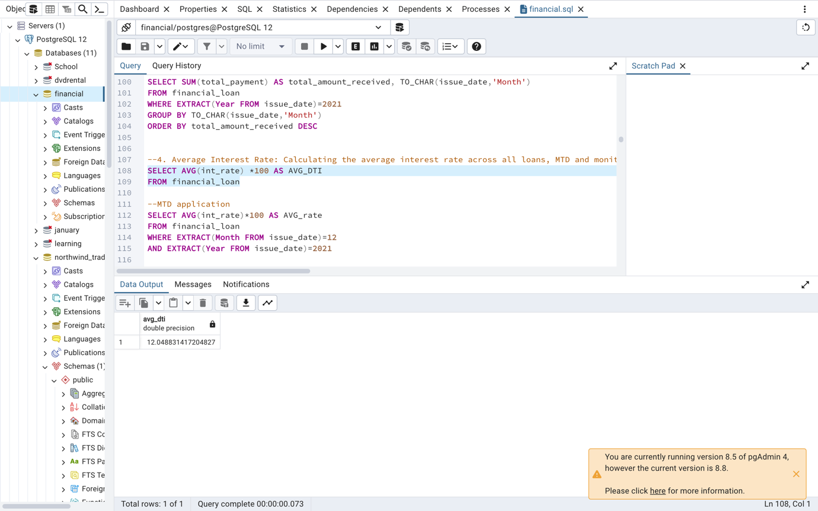

MTD Average Interest Rate

SELECT AVG(int_rate)*100 AS AVG_rate

FROM financial_loan

WHERE EXTRACT(Month FROM issue_date)=12

AND EXTRACT(Year FROM issue_date)=2021

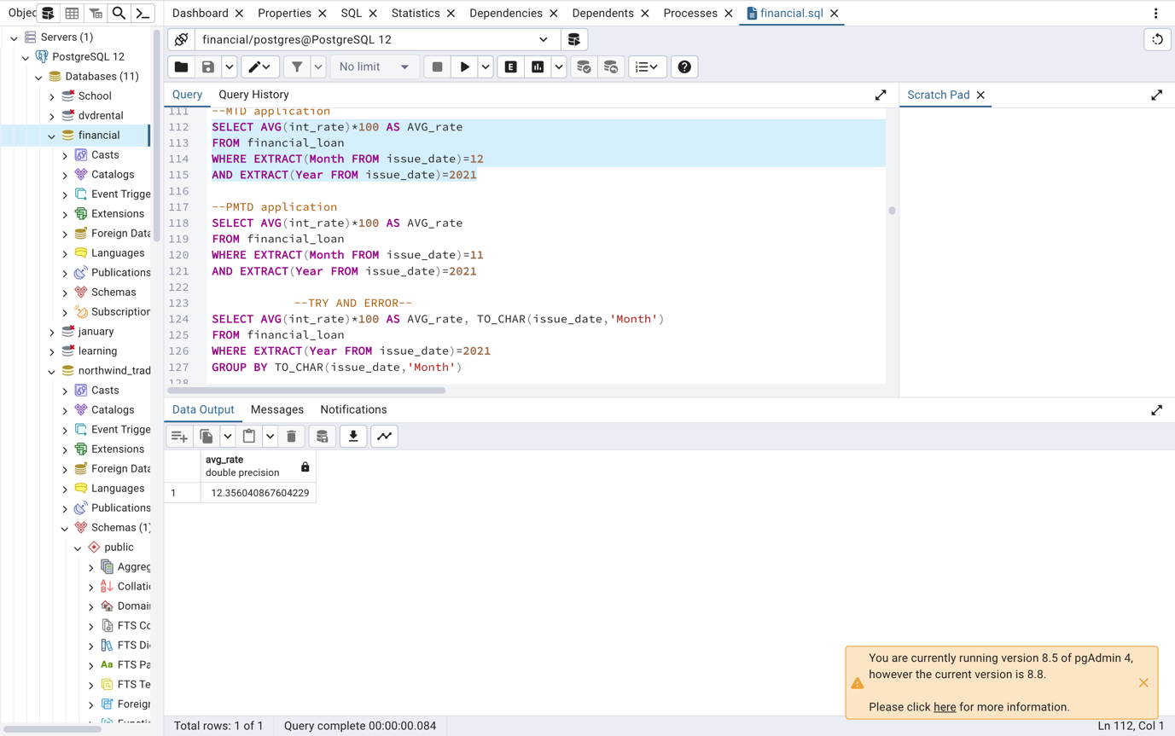

PMTD Average Interest Rate

SELECT AVG(int_rate)*100 AS AVG_rate

FROM financial_loan

WHERE EXTRACT(Month FROM issue_date)=11

AND EXTRACT(Year FROM issue_date)=2021

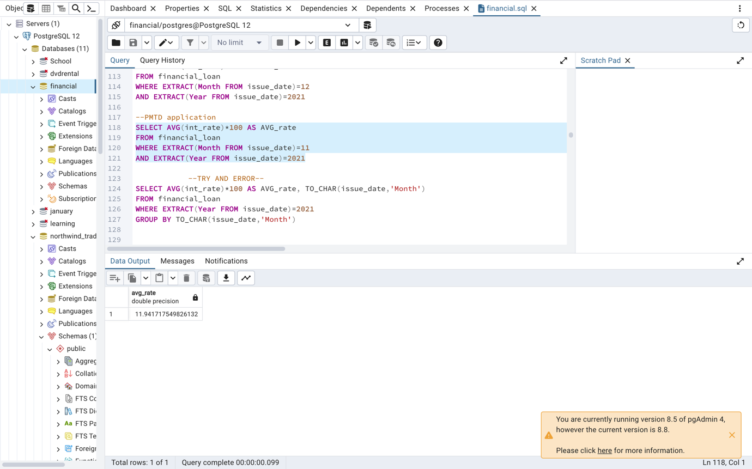

Average Debt to Income

SELECT AVG(dti)*100 AS AVG_DTI

FROM financial_loan

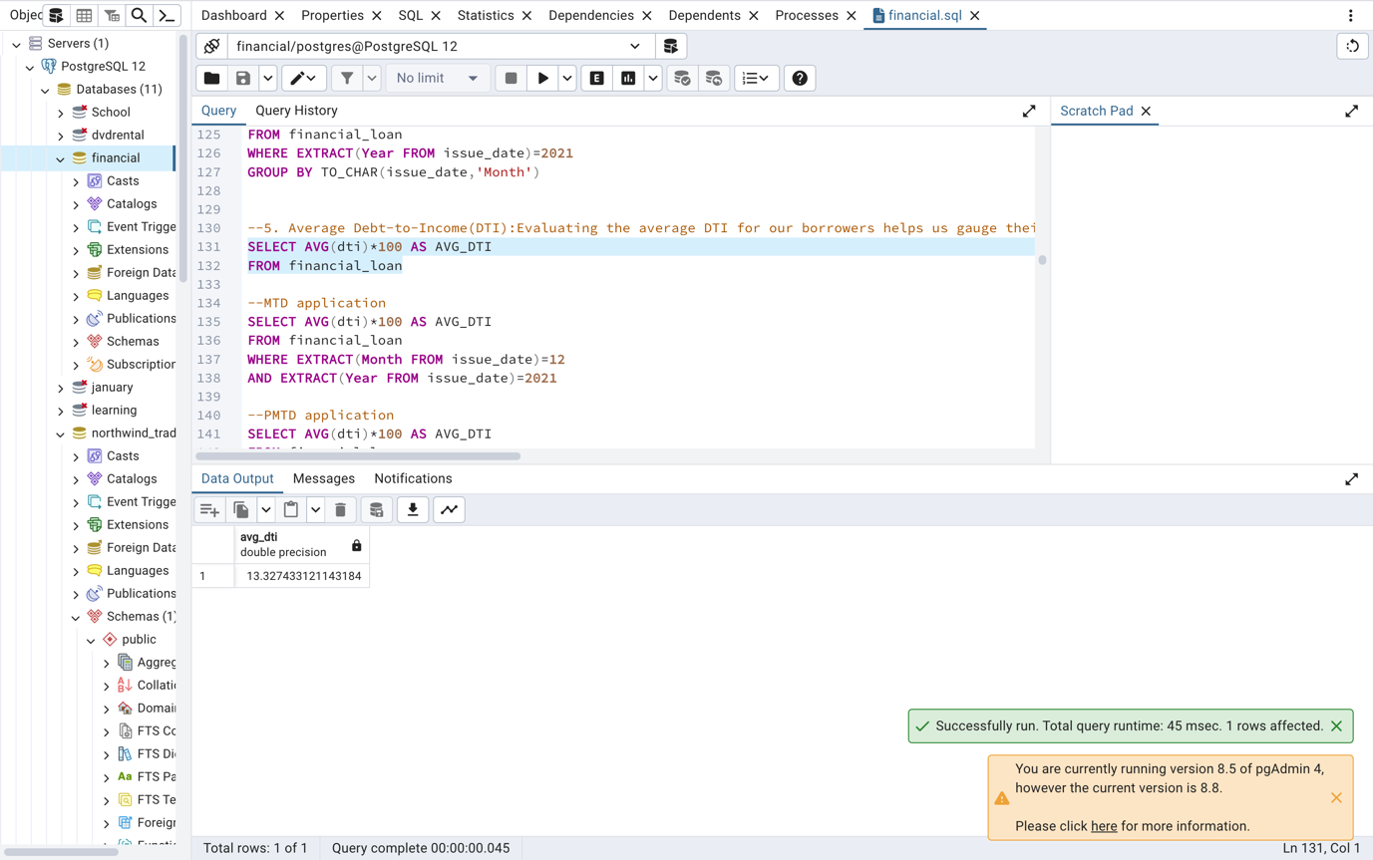

MTD Average Interest Rate

SELECT AVG(dti)*100 AS AVG_DTI

FROM financial_loan

WHERE EXTRACT(Month FROM issue_date)=12

AND EXTRACT(Year FROM issue_date)=2021

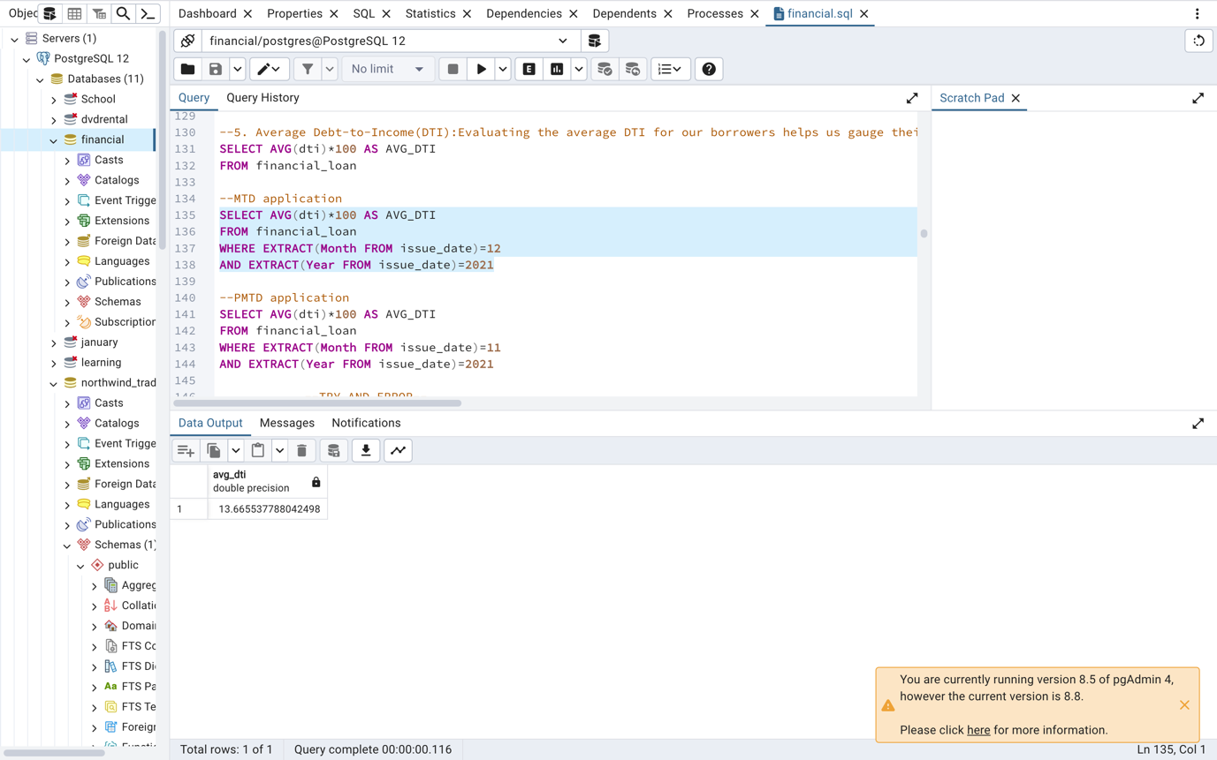

PMTD Average Interest Rate

SELECT AVG(dti)*100 AS AVG_DTI

FROM financial_loan

WHERE EXTRACT(Month FROM issue_date)=11

AND EXTRACT(Year FROM issue_date)=2021

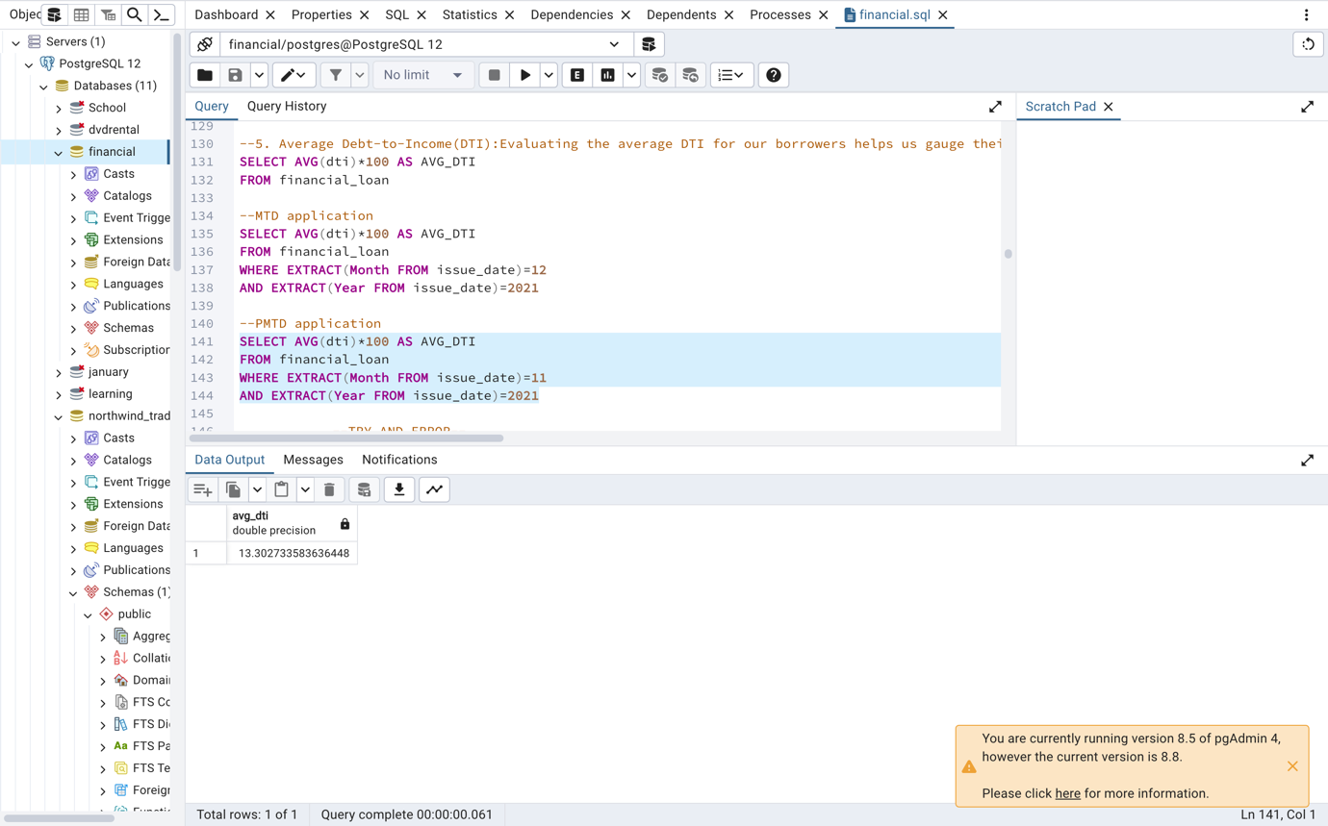

GOOD LOAN ISSUED

Good Loan Percentage

SELECT(COUNT (CASE WHEN loan_status='Fully Paid' OR loan_status='Current' THEN id

END)*100.0)/

COUNT(id) AS Good_Loan_Percentage

FROM financial_loan

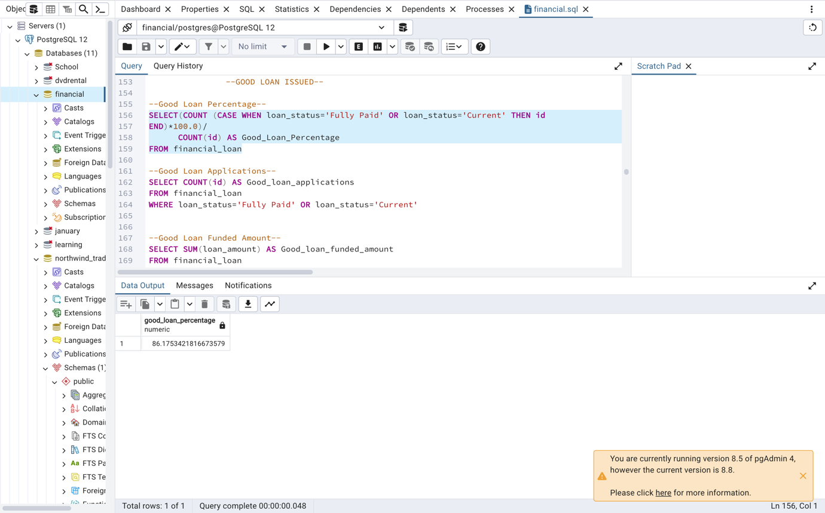

Good Loan Applications

SELECT COUNT(id) AS Good_loan_applications

FROM financial_loan

WHERE loan_status='Fully Paid' OR loan_status='Current'

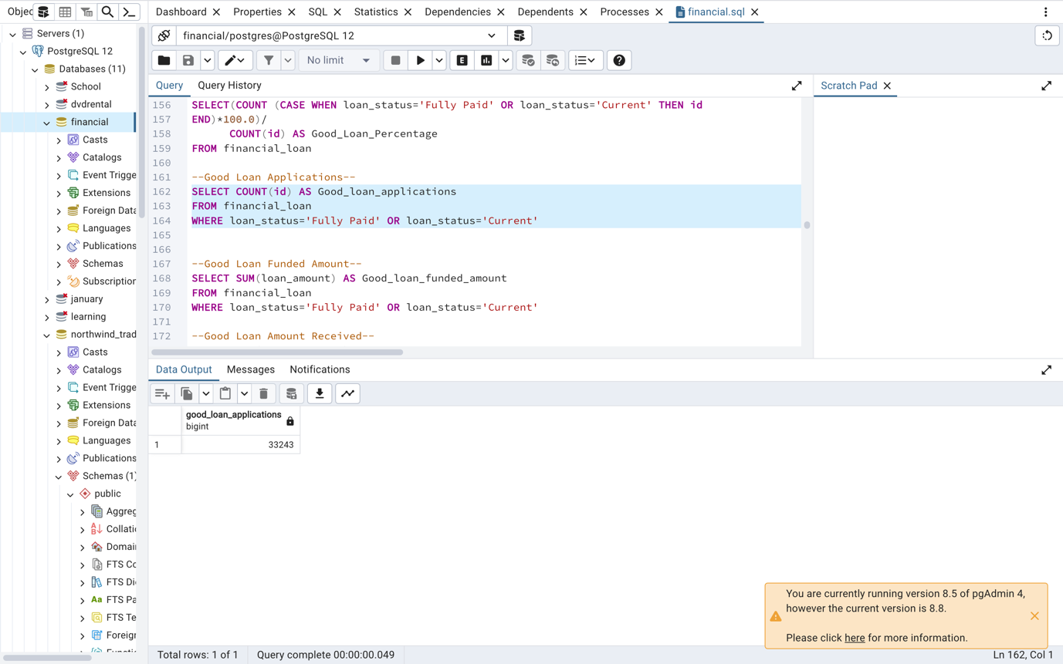

Good Loan Funded Amount

SELECT SUM(loan_amount) AS Good_loan_funded_amount

FROM financial_loan

WHERE loan_status='Fully Paid' OR loan_status='Current'

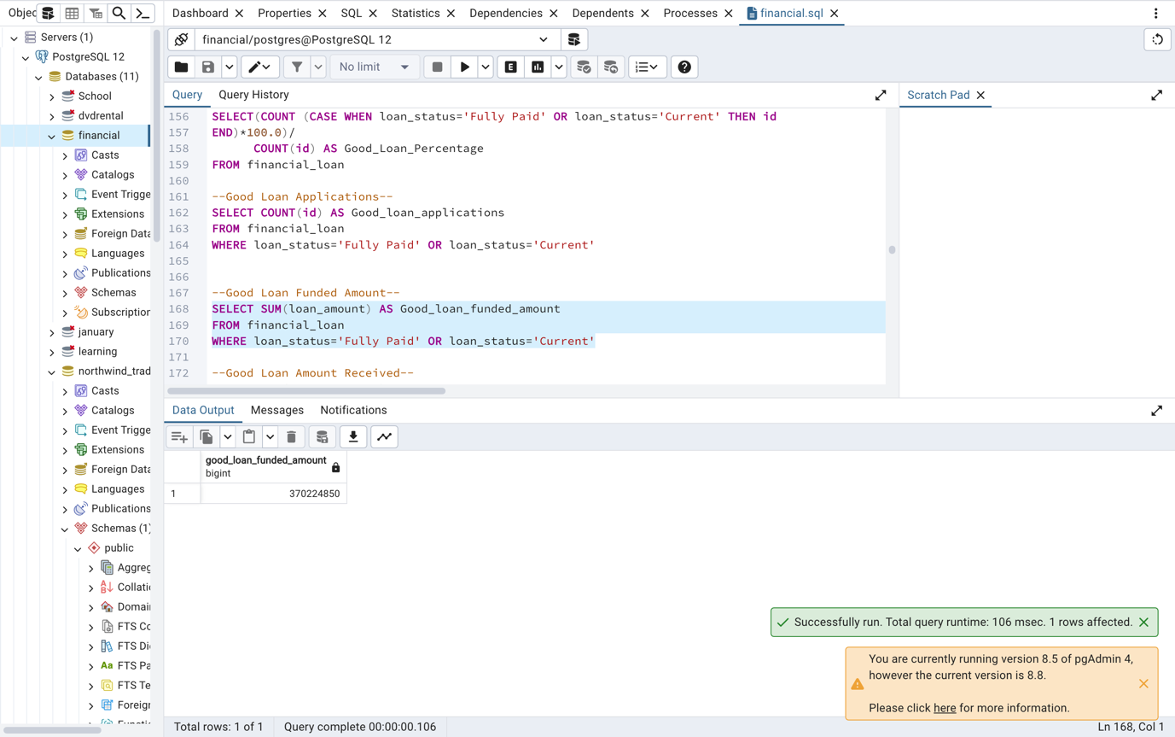

Good Loan Amount Received

SELECT SUM(total_payment) AS Good_loan_amount_received

FROM financial_loan

WHERE loan_status='Fully Paid' OR loan_status='Current'

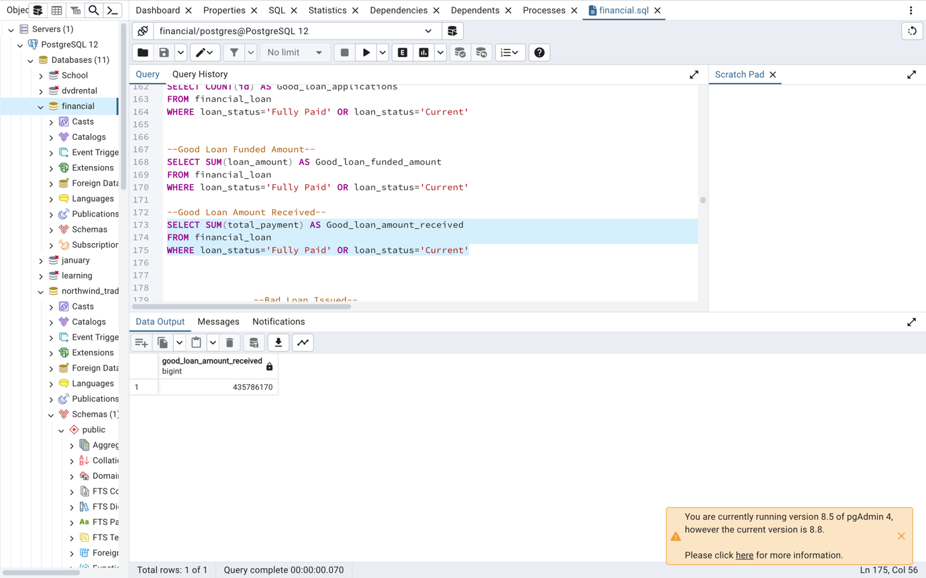

BAD LOAN ISSUED

Bad Loan Percentage

SELECT(COUNT (CASE WHEN loan_status='Charged Off' THEN id

END)*100.0)/

COUNT(id) AS Bad_Loan_Percentage

FROM financial_loan

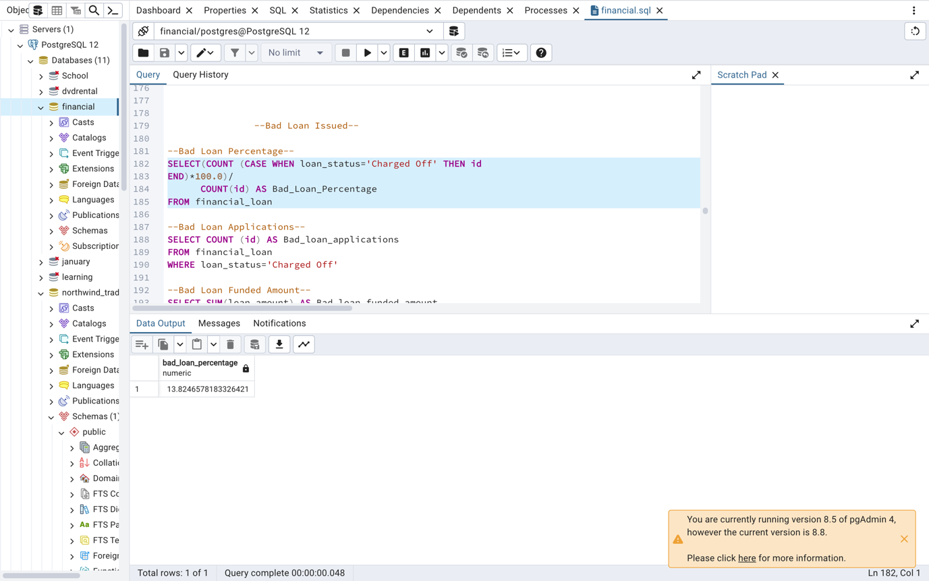

Bad Loan Applications

SELECT COUNT (id) AS Bad_loan_applications

FROM financial_loan

WHERE loan_status='Charged Off'

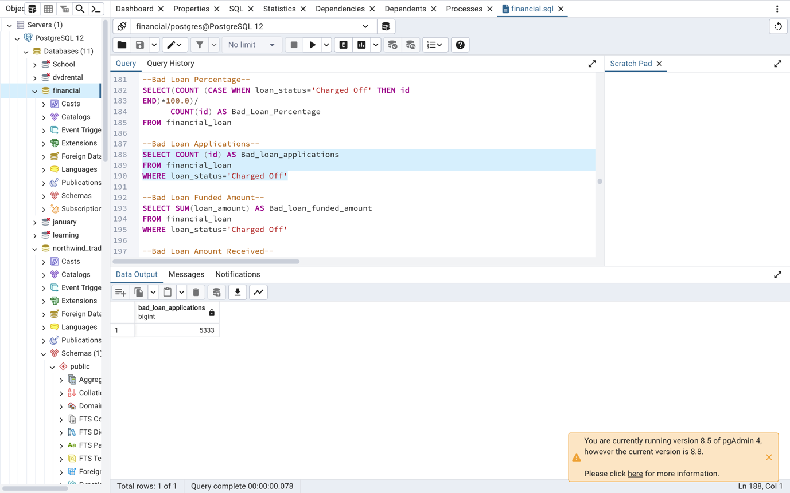

Bad Loan Funded Amount

SELECT SUM(loan_amount) AS Bad_loan_funded_amount

FROM financial_loan

WHERE loan_status='Charged Off'

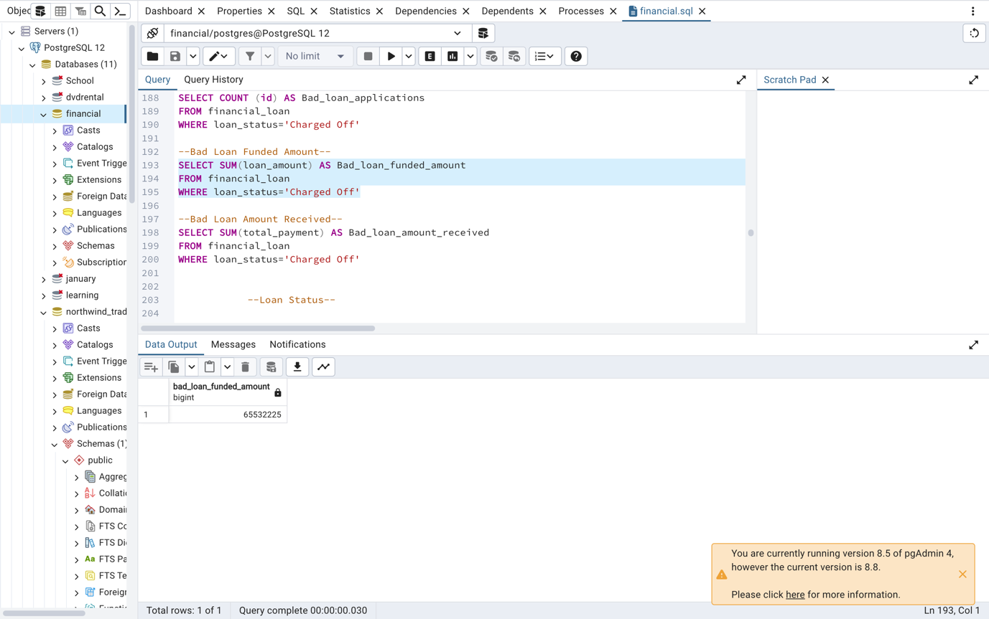

Bad Loan Amount Received

SELECT SUM(total_payment) AS Bad_loan_amount_received

FROM financial_loan

WHERE loan_status='Charged Off'

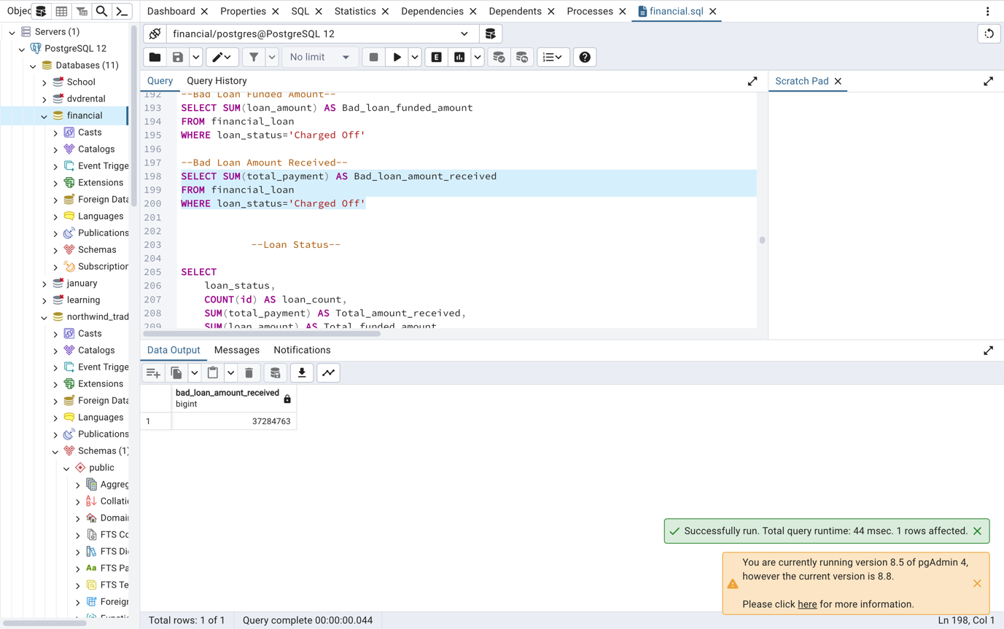

**LOAN STATUS**

SELECT

loan_status,

COUNT(id) AS loan_count,

SUM(total_payment) AS Total_amount_received,

SUM(loan_amount) AS Total_funded_amount,

AVG(int_rate*100) AS Interest_rate,

AVG(dti*100) AS DTI

FROM financial_loan

GROUP BY loan_status

ORDER BY loan_count

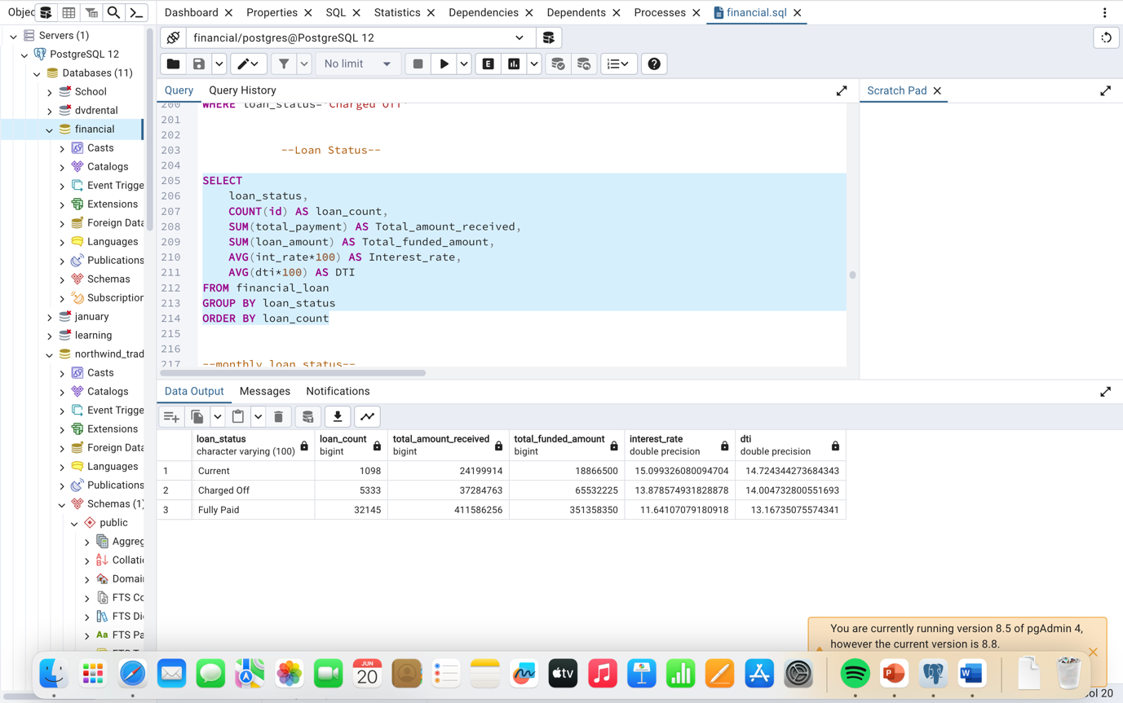

Monthly Loan Status

SELECT

loan_status,

SUM(total_payment) AS MTD_total_amount_received,

SUM(loan_amount) AS MTD_total_funded_amount

FROM financial_loan

WHERE EXTRACT(Month FROM issue_date)=12

AND EXTRACT(Year FROM issue_date)=2021

GROUP BY loan_status

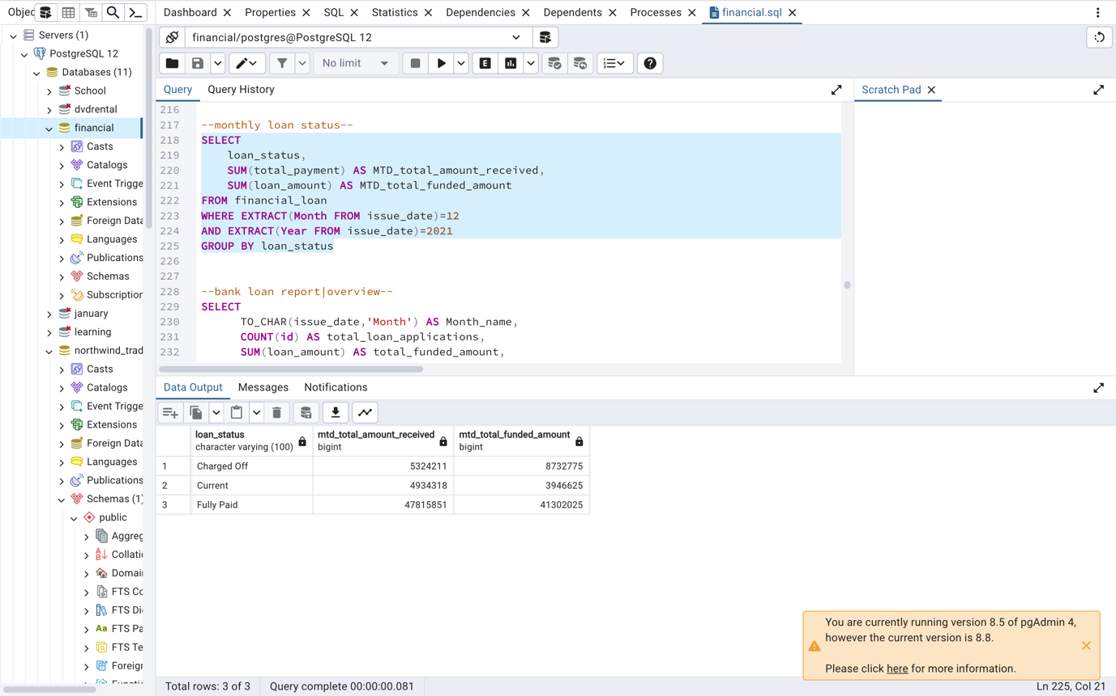

BANK LOAN REPORT | OVERVIEW

SELECT

EXTRACT('Month' FROM issue_date) AS month_number,

TO_CHAR(issue_date,'Month') AS month_name,

COUNT(id) AS total_loan_applications,

SUM(loan_amount) AS total_funded_amount,

SUM(total_payment) AS total_amount_received

FROM financial_loan

WHERE EXTRACT (Year FROM issue_date)=2021

GROUP BY month_number,month_name

ORDER BY month_number

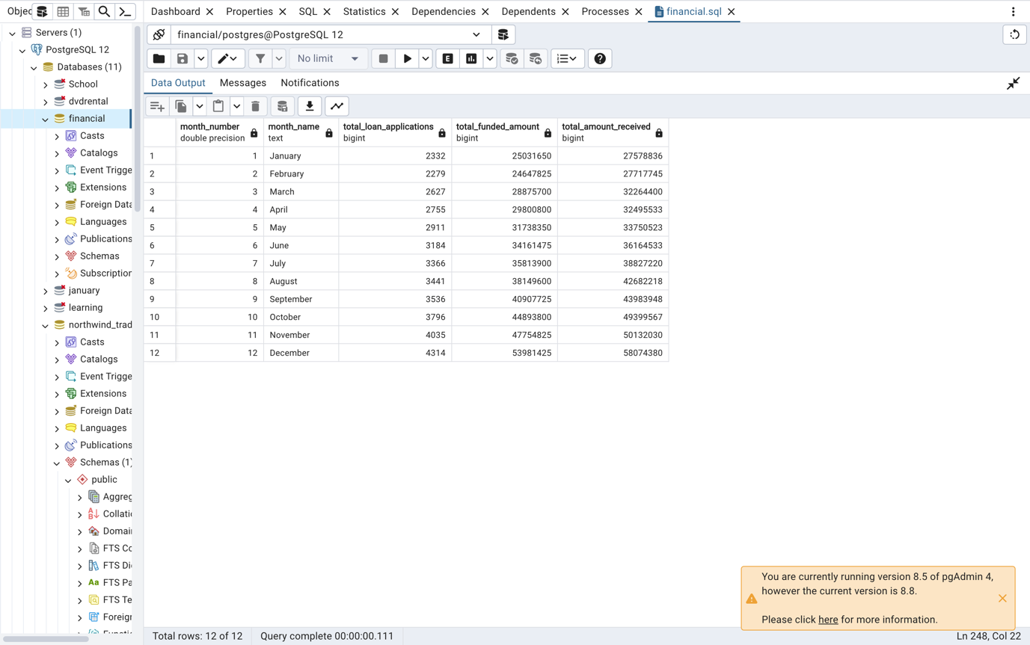

STATE

SELECT address_state,COUNT(id) AS total_loan_applications,

SUM(loan_amount) AS total_funded_amount,

SUM(total_payment) AS total_amount_received

FROM financial_loan

GROUP BY address_state

ORDER BY address_state

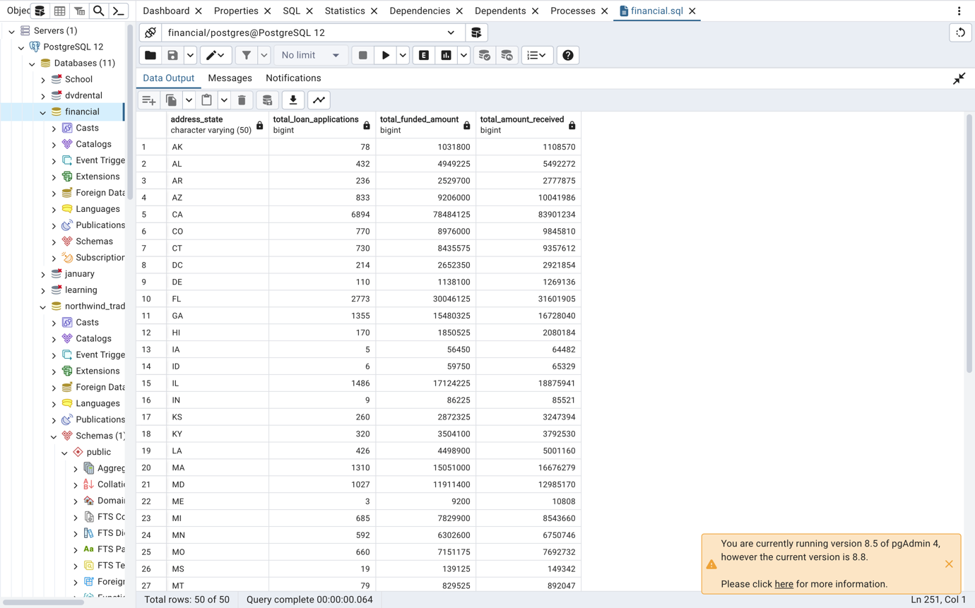

TERM

SELECT term AS TERM,

COUNT(id) AS Total_loan_applications,

SUM(loan_amount) AS total_funded_amount,

SUM(total_payment) AS total_amount_received

FROM financial_loan

GROUP BY TERM

ORDER BY TERM

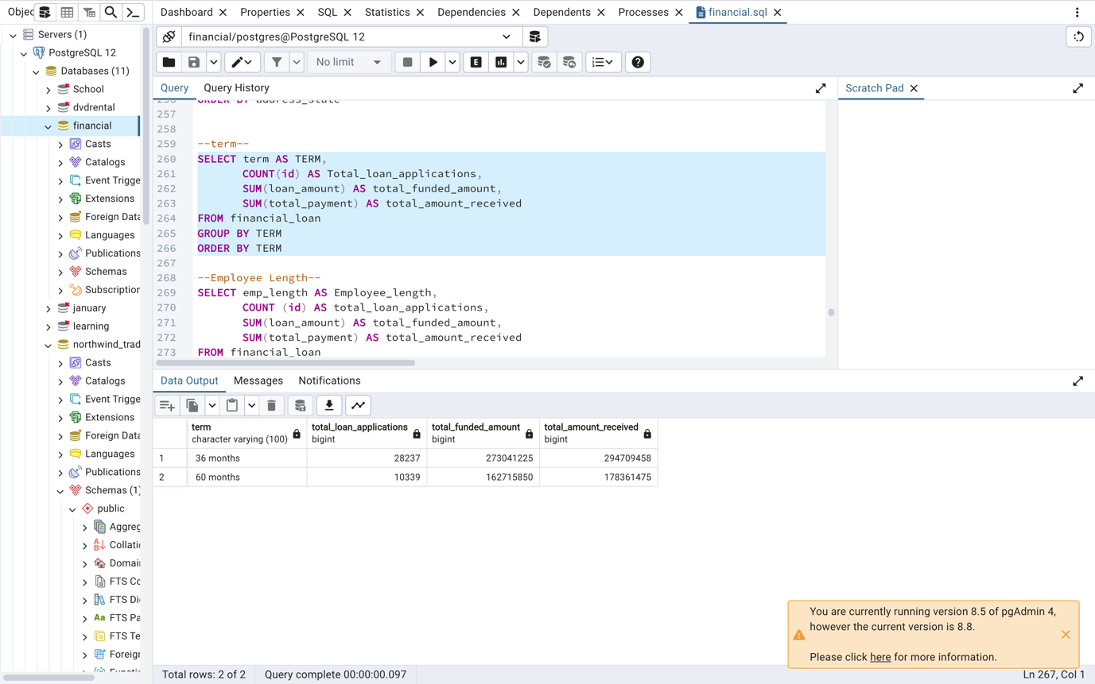

EMPLOYEE LENGTH

SELECT emp_length AS Employee_length,

COUNT (id) AS total_loan_applications,

SUM(loan_amount) AS total_funded_amount,

SUM(total_payment) AS total_amount_received

FROM financial_loan

GROUP BY Employee_length

ORDER BY Employee_length

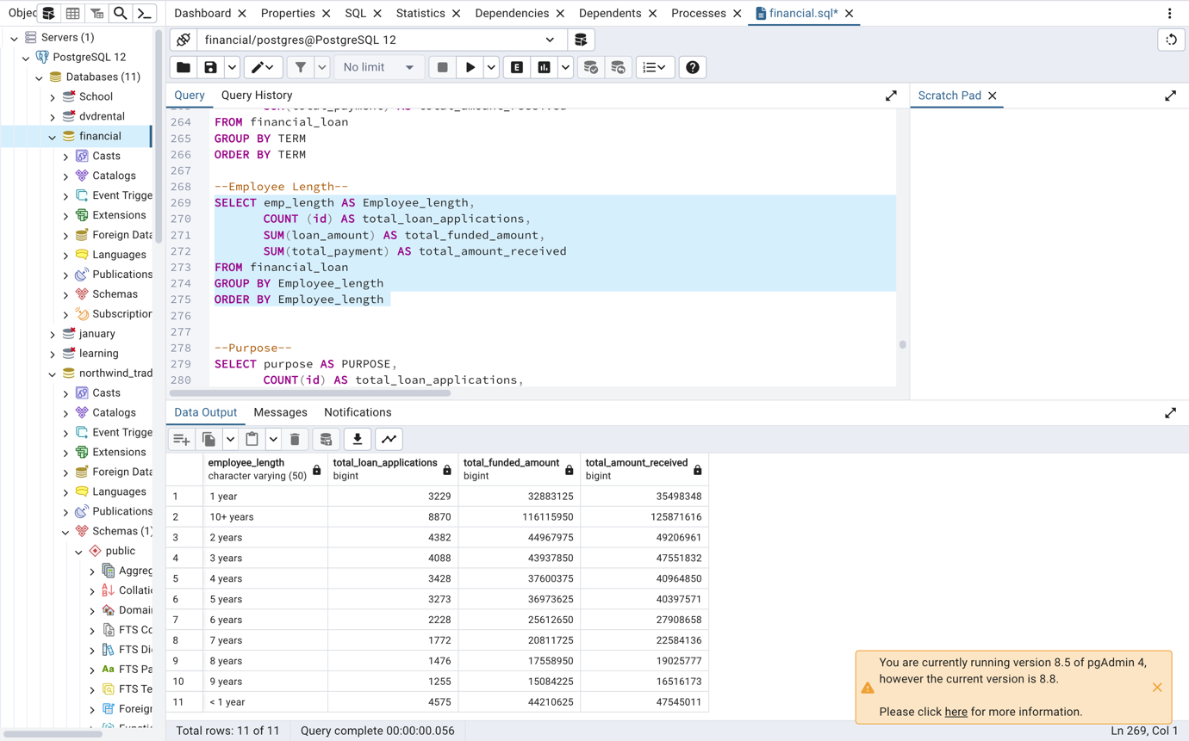

PURPOSE

SELECT purpose AS PURPOSE,

COUNT(id) AS total_loan_applications,

SUM(loan_amount) AS total_funded_amount,

SUM(total_payment) AS total_amount_received

FROM financial_loan

GROUP BY PURPOSE

ORDER BY total_loan_applications

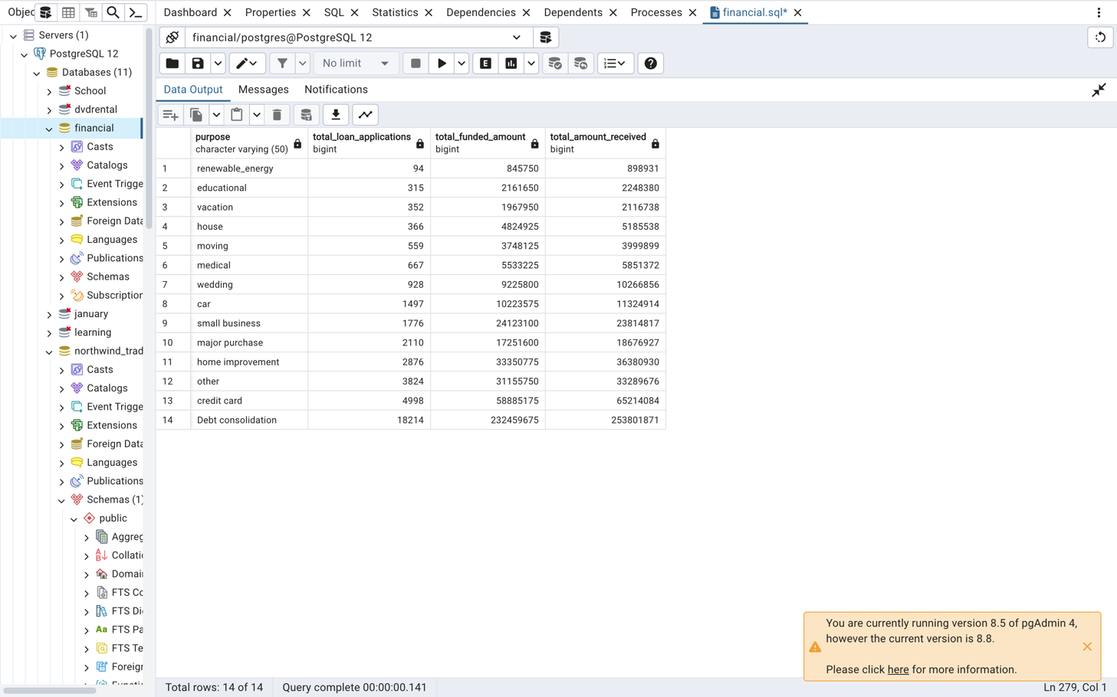

HOME OWNERSHIP

SELECT home_ownership AS Home_ownership,

COUNT(id) AS total_loan_applications,

SUM(loan_amount) AS total_funded_amount,

SUM(total_payment) AS total_amount_received

FROM financial_loan

GROUP BY home_ownership

ORDER BY total_loan_applications

